Vincent Ryan

7/7/2024

Module 8 - Python SQL 2

This assignment was really a lot to learn but I’m glad I got to where I did. Yes, I know it’s late; I’m sorry I couldn’t get it done in time I still wanted to finish. Here are some super specifics I’ve learned:

1. Things we consider “values” cannot be evaluated by the Python connection stream without quotes.
2. Exactly opposite of that, variables requires you to not have quotes. This makes inputting values challenging, because if you’re only updating one variable, you can’t use a string of a tuple because it can’t contain that trailing “,” that Python requires.
3. This after a lot of trial and error makes the easiest way to create an update formula as just inputting strings. Those strings must be a quote where the first and last character were parenthesis.
4. Delete, Update, and Insert are nearly identical to each other but should just be separate formulas.
5. Working SQL while committing data for class while still learning is challenging. You have to undo many things.
6. You can’t add an item with a new foreign key, without creating the thing that foreign key is first hence the studio and genre calls before.

**Code (in split view for sake of space)**

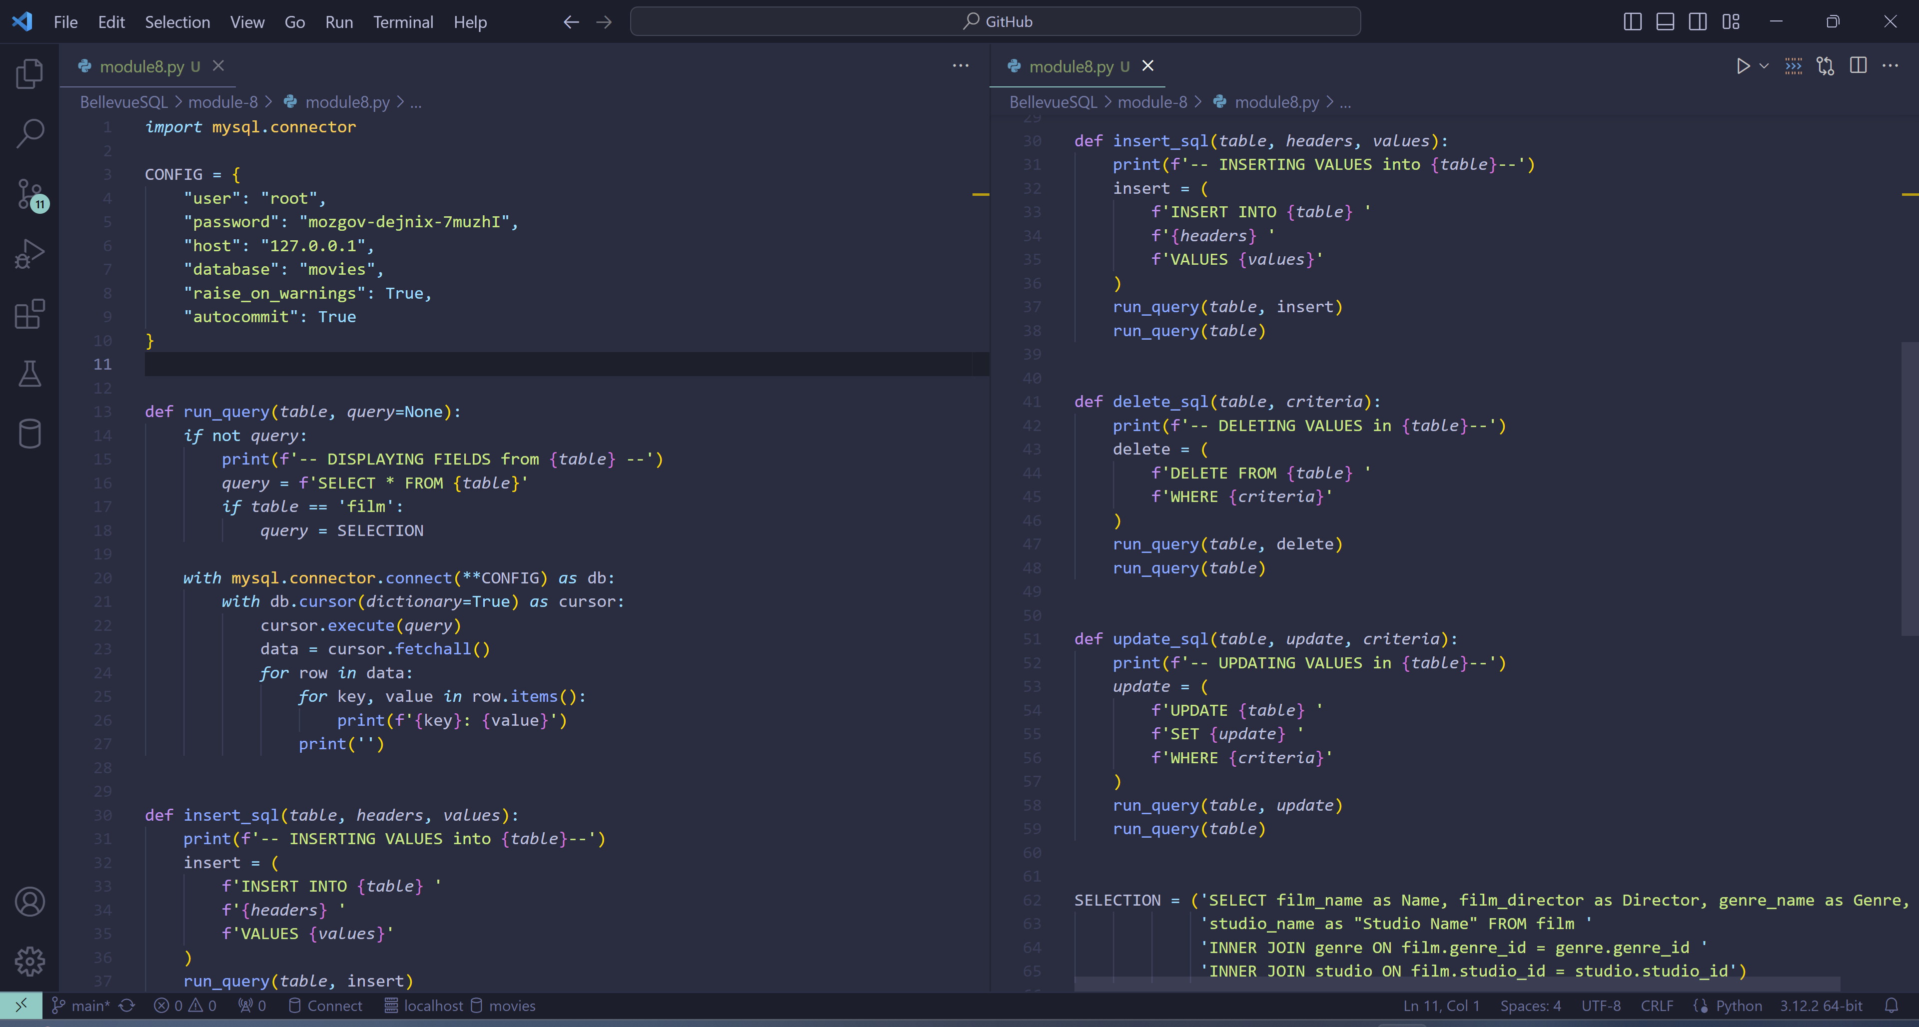

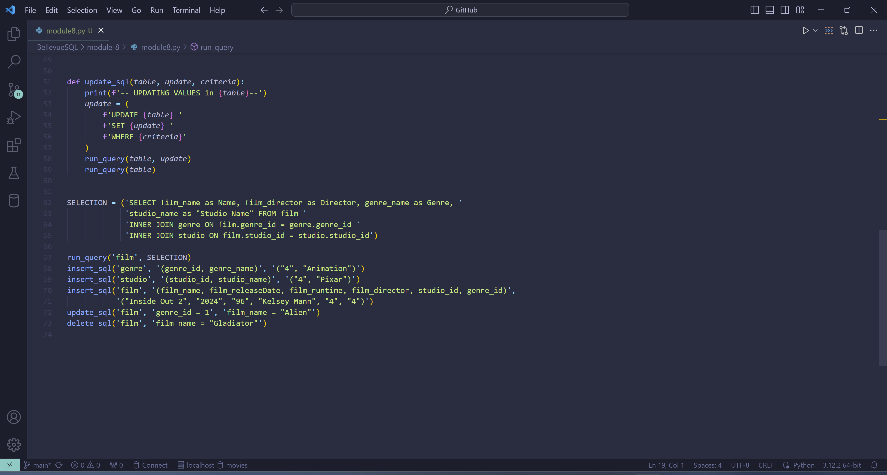

**Python Print Results:**

Name: Gladiator

Director: Ridley Scott

Genre: Drama

Studio Name: Universal Pictures

Name: Alien

Director: Ridley Scott

Genre: SciFi

Studio Name: 20th Century Fox

Name: Get Out

Director: Jordan Peele

Genre: Horror

Studio Name: Blumhouse Productions

-- INSERTING VALUES into genre--

-- DISPLAYING FIELDS from genre --

genre_id: 1

genre_name: Horror

genre_id: 2

genre_name: SciFi

genre_id: 3

genre_name: Drama

genre_id: 4

genre_name: Animation

-- INSERTING VALUES into studio--

-- DISPLAYING FIELDS from studio --

studio_id: 1

studio_name: 20th Century Fox

studio_id: 2

studio_name: Blumhouse Productions

studio_id: 3

studio_name: Universal Pictures

studio_id: 4

studio_name: Pixar

-- INSERTING VALUES into film--

-- DISPLAYING FIELDS from film --

Name: Gladiator

Director: Ridley Scott

Genre: Drama

Studio Name: Universal Pictures

Name: Alien

Director: Ridley Scott

Genre: SciFi

Studio Name: 20th Century Fox

Name: Get Out

Director: Jordan Peele

Genre: Horror

Studio Name: Blumhouse Productions

Name: Inside Out 2

Director: Kelsey Mann

Genre: Animation

Studio Name: Pixar

-- UPDATING VALUES in film--

-- DISPLAYING FIELDS from film --

Name: Gladiator

Director: Ridley Scott

Genre: Drama

Studio Name: Universal Pictures

Name: Alien

Director: Ridley Scott

Genre: Horror

Studio Name: 20th Century Fox

Name: Get Out

Director: Jordan Peele

Genre: Horror

Studio Name: Blumhouse Productions

Name: Inside Out 2

Director: Kelsey Mann

Genre: Animation

Studio Name: Pixar

-- DELETING VALUES in film--

-- DISPLAYING FIELDS from film --

Name: Alien

Director: Ridley Scott

Genre: Horror

Studio Name: 20th Century Fox

Name: Get Out

Director: Jordan Peele

Genre: Horror

Studio Name: Blumhouse Productions

Name: Inside Out 2

Director: Kelsey Mann

Genre: Animation

Studio Name: Pixar